# COMP3500: Operating Systems Design

**Exercise 1:** Please write down two operating system services.

**🟊🟊Exercise 2 (Plickers):** printf() must call the write() system call for the following reasons **except:**

1. printf() uses I/O resources managed by operating systems
2. printf() relies on an output device managed by device management
3. printf() depends on a service offered at the user mode
4. 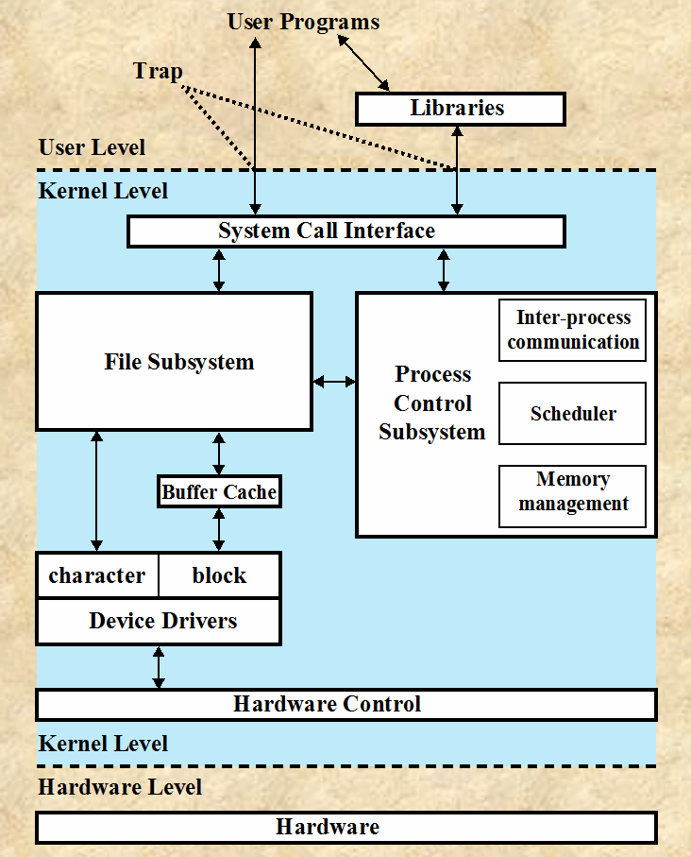printf() calls a service implemented in the kernel

**🟊Exercise 3 (Plickers):** The monolithic kernel has the following strengths **except**:

1. High performance
2. Easy to port the operating system to new architectures
3. Low overhead of user space to kernel space communication

**Exercise 4 (2-Min Group Discussion):** What are the pros and cons of the microkernel system structure?

2_14.pdf

**Exercise 5:** Given a monolithic kernel and a microkernel structure, which one should we use to build an OS for embedded systems (e.g., real-time robotic systems)? Why?